Retrieving the data using sql select statements

- Determine the Structure of DEPT Table and its Contents.

Describe dept;

Output:-

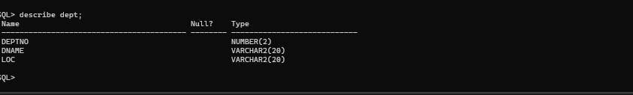

Select * from dept;

Output:-

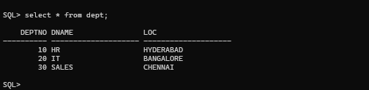

- Determine the Structure of EMP Table and its Contents.

Describe emp;

Output:-

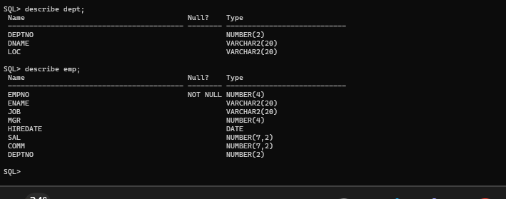

Select * from emp;

Output:-

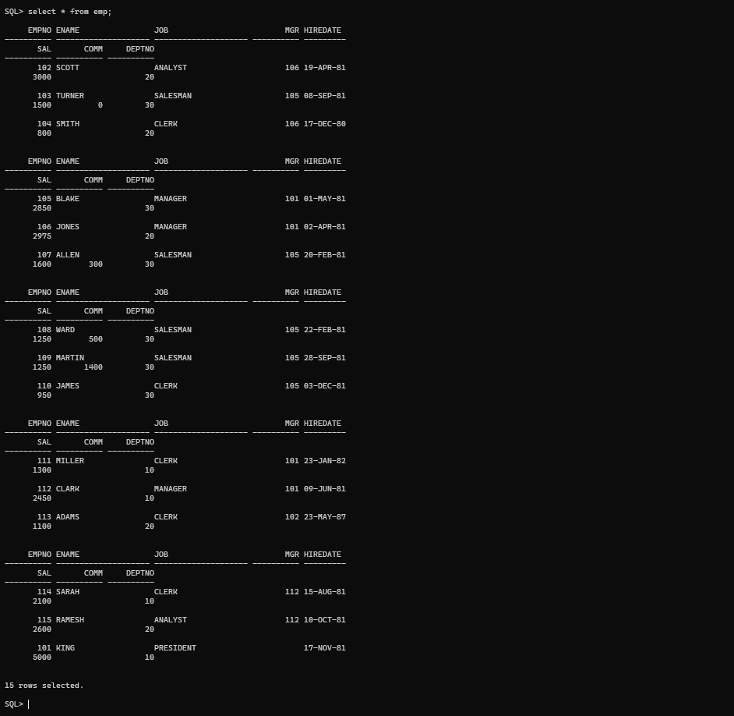

- Display the ENAME and DEPTNO from EMP table whose EMPNO is 7788.
Select ename,deptno from emp where empno=7788;
Output:-
